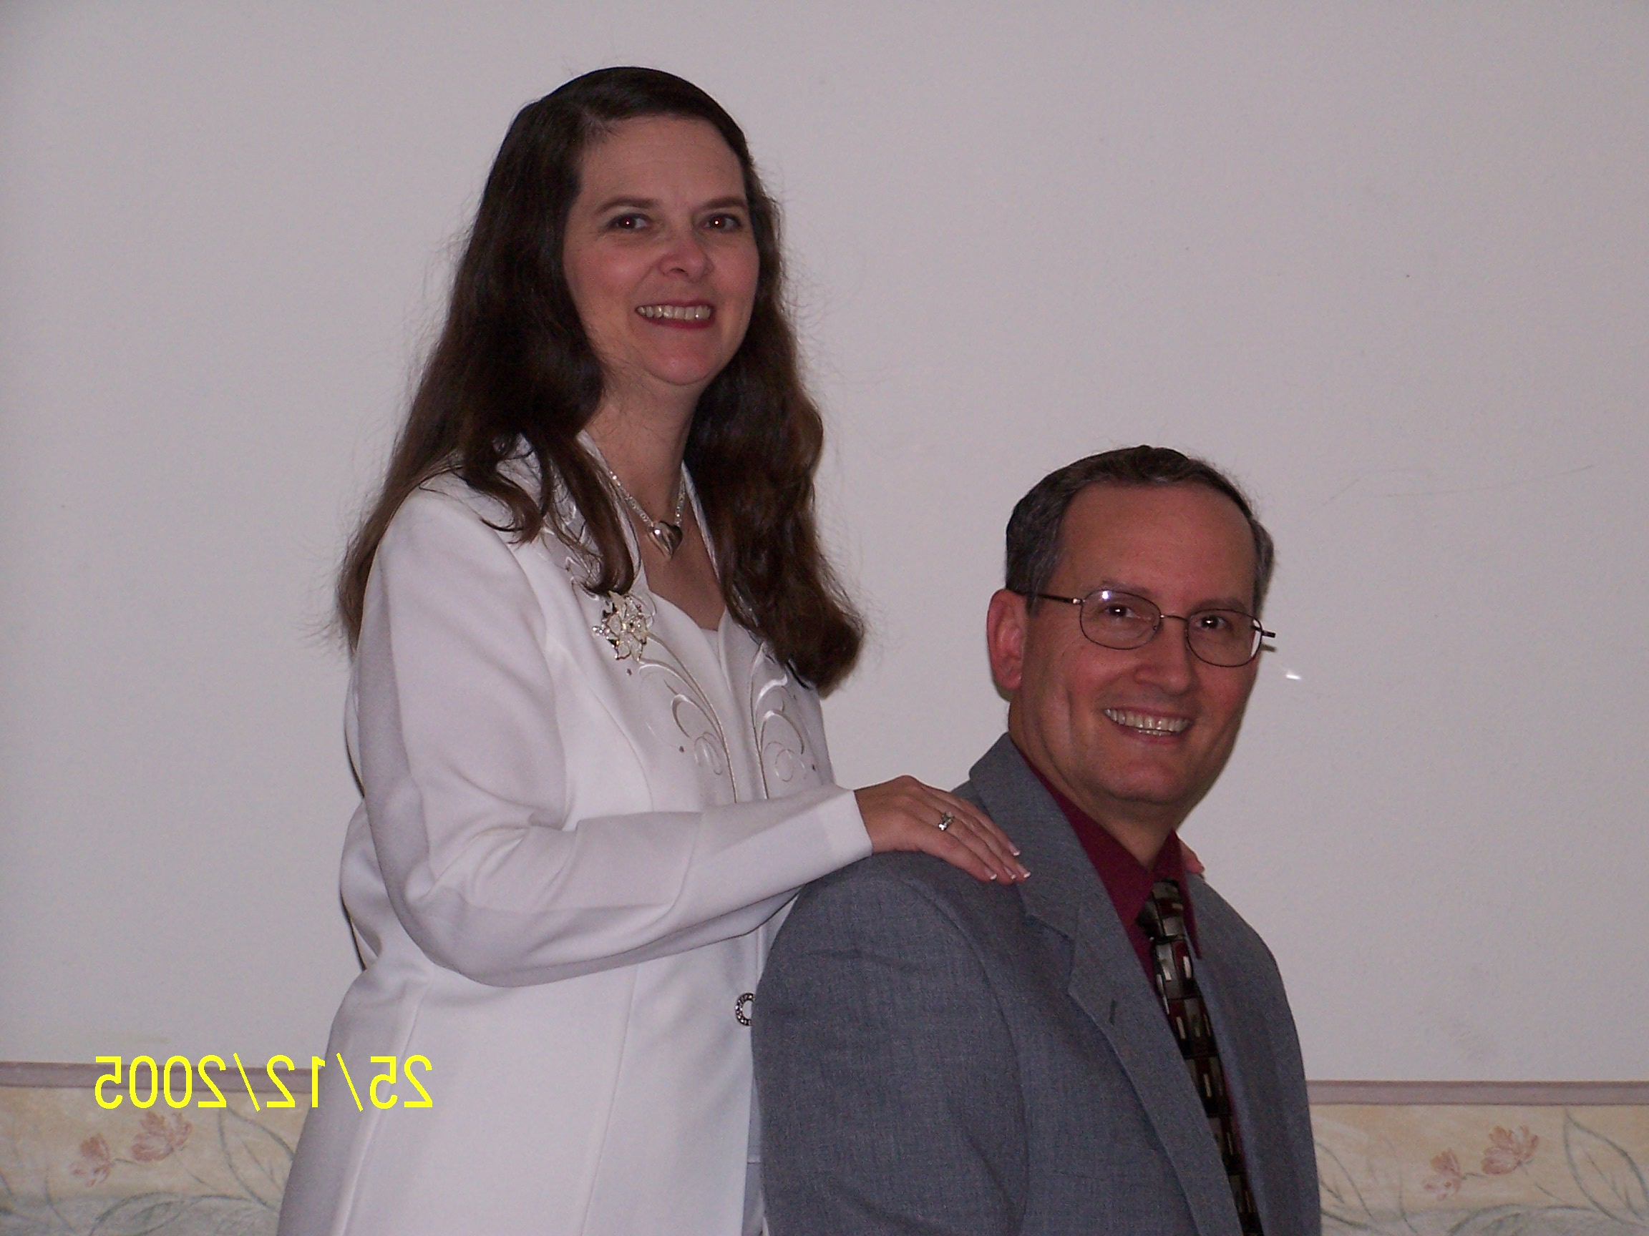
Mexico missions is growing! Bethesda Baptist of Monterrey, had their missions conference in Oct. with $112,110.00 (USD) promised to missions!
Even the work in McAllen is giving more to missions. We gave $15,000 to missions last year and promised $19,000 this year!
Real growth is being experienced in the work in McAllen. In the month of Sept., we saw our average in Sunday School shoot up to 78 and we had 2 saved!
Real trials were also experienced with the devil fighting in every way. One family left, several others had family problems, teachers got discouraged, several got sick and Michelle’s health worsened!
You are a vital part of our ministry. Though you did not know of our problems, you prayed, you supported us, you sent cards of encouragement and love, that helped so much! Thank you!

Christ was honored through all our problems, for we kept preaching the Word, winning souls and discipling those who were saved.
Health problems - keep Michelle in your prayers! She has had two seizures since our last letter, is suffering from fibromyalgia, her asthma has worsened, and she is currently receiving IV antibiotics for a very resistant UTI. This has caused the C-diff to return!
Reporting to churches has been difficult these last few months, yet we will strive to do better in 2019. If you can receive our letters by way of e-mail, please let us know!
Institute ministries are doing great in most of the 16 institutes. McAllen has 6 students in special courses that started in September!
Souls is what our ministry is all about. Just this month, I won a lady to the Lord one week before she died of cancer! Pray for souls to be saved!
Thanksgiving this year was blessed with 96 in attendance at our special service, and 2 were saved!
May Christ be glorified this Christmas.
And may the new year bring His blessing on all we do for Him!
Season’s Greetings is what the world tells us, but we love to respond “Merry Christmas” because without Christ, there would be no Christmas!

In Him,
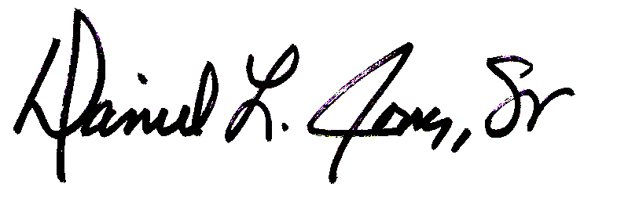
Daniel and Michelle Jones

Received Sept., Oct., & Nov. of 2018

Support: $_________________

Institute in Oct. & Nov. of 2018
$_________________

CL Jones Memorial Fund in Oct. & Nov.
$_________________

¡Muchas Gracias! Thank you!

Sending Church: Worth Baptist Church - P.O. Box 15141 - Fort Worth, Texas - 76119
Support address: I.B.F.I. Mission Agency - 724 North Jim Wright Fwy. - Fort Worth, Texas — 76108
Address: 10312 N. 26^{t}h Street, McAllen, Texas - 78504
Phones: Cell: DLJ (956)212-5016; MJ (956)821-4958 - E-mail: dljsratrgv@outlook.com

